**US Accidents Query Solutions**

This document contains the updated query solutions along with other queries as suggested by our mentor, Mr. Apurba. You can find the updated query versions (query 3,4,6,13), with their heading highlighted as yellow

## Query 1

with cte1 as

(select state , severity, count(severity) as severity_1 from us_accident_v3 where severity = 1 group by severity, state),

cte2 as

(select state , severity, count(severity) as severity_2 from us_accident_v3 where severity = 2 group by severity, state),

cte3 as

(select state, severity, count(severity) as severity_3 from us_accident_v3 where severity = 3 group by severity, state),

cte4 as

(select state, severity, count(severity) as severity_4 from us_accident_v3 where severity = 4 group by severity, state)

select a.state, severity_1, severity_2, severity_3, severity_4 from cte1 a

join cte2 b

on a.state = b.state

join cte3 c

on a.state = c.state

join cte4 d

on a.state = d.state

order by a.state

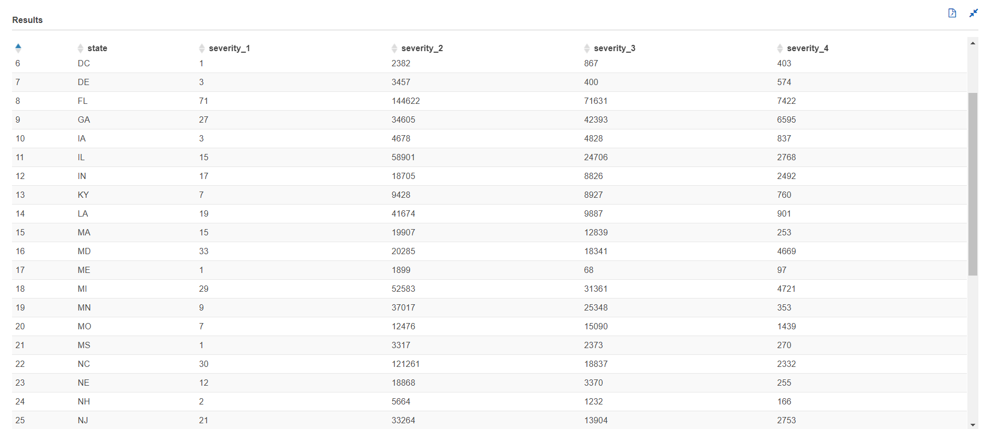

## Query 3 (Updated)

with cte1 as (select severity, avg(date_diff('second', start_time, end_time)) as avg_dur, stddev_pop(date_diff('second', start_time, end_time)) as std_dur, max(date_diff('second', start_time, end_time)) as max_dur from us_accident_v3 group by severity order by severity)selectkv4[4] as avg_dur_sev_4,kv3[3] as avg_dur_sev_3,kv2[2] as avg_dur_sev_2,kv1[1] as avg_dur_sev_1,pq4[4] as std_dur_sev_4,pq3[3] as std_dur_sev_3,pq2[2] as std_dur_sev_2,pq1[1] as std_dur_sev_1,ms4[4] as max_dur_sev_4,ms3[3] as max_dur_sev_3,ms2[2] as max_dur_sev_2,ms1[1] as max_dur_sev_1from (select map_agg(severity, avg_dur/60) kv4, map_agg(severity, avg_dur/60) kv3, map_agg(severity, avg_dur/60) kv2, map_agg(severity, avg_dur/60) kv1, map_agg(severity, std_dur/60) pq4, map_agg(severity, std_dur/60) pq3, map_agg(severity, std_dur/60) pq2, map_agg(severity, std_dur/60) pq1, map_agg(severity, max_dur/60) ms4, map_agg(severity, max_dur/60) ms3, map_agg(severity, max_dur/60) ms2, map_agg(severity, max_dur/60) ms1 from cte1)

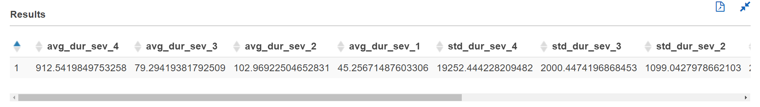

## Query 4 (Updated)

with cte1 as

(select date_format(start_time, '%Y-%m-%d') AS date,severity,weather_condition,

case

when weather_condition = 'Clear' then 'good'

when weather_condition like 'Cloudy%' then 'good'

when weather_condition = 'Drizzle' then 'good'

when weather_condition = 'Drizzle / Windy' then 'good'

when weather_condition like 'Fair%' then 'good'

when weather_condition = 'Haze' then 'good'

when weather_condition like 'Light%' then 'good'

when weather_condition = 'Mist' then 'good'

when weather_condition like 'Mostly%' then 'good'

when weather_condition = 'N/A Precipitation' then 'good'

when weather_condition = 'Overcast' then 'good'

when weather_condition like 'Partial%' then 'good'

when weather_condition like 'Partly%' then 'good'

when weather_condition = 'Patches of Fog' then 'good'

when weather_condition = 'Scattered Clouds' then 'good'

when weather_condition = 'Shallow Fog' then 'good'

when weather_condition = 'Showers in the Vicinity' then 'good'

when weather_condition = 'Small Hail' then 'good'

when weather_condition = 'Thunder in the Vicinity' then 'good'

else 'bad' end as weather_type

from us_accident_v3),

cte2 as

(select *,

case

when severity = 1 and weather_type = 'good' then 'sev1_good'

when severity = 2 and weather_type = 'good' then 'sev2_good'

when severity = 3 and weather_type = 'good' then 'sev3_good'

when severity = 4 and weather_type = 'good' then 'sev4_good'

when severity = 1 and weather_type = 'bad' then 'sev1_bad'

when severity = 2 and weather_type = 'bad' then 'sev2_bad'

when severity = 3 and weather_type = 'bad' then 'sev3_bad'

when severity = 4 and weather_type = 'bad' then 'sev4_bad'

else 'unknown_weather' end as good_bad_sev

from cte1),

cte3 as

(select date,good_bad_sev,count(*) as number_of_accident from cte2 group by date,good_bad_sev

order by date,good_bad_sev asc),

cte4 as

(select a.date,good_bad_sev, a.number_of_accident, cast(a.number_of_accident as double)*100/b.tot_accident_good as percent_accident from cte3 a

inner join

(select date, count(*) as tot_accident_good from cte2

where weather_type = 'good'

group by date) b

on a.date = b.date

where good_bad_sev in ('sev1_good', 'sev2_good', 'sev3_good', 'sev4_good')),

cte5 as

(select a.date,good_bad_sev, a.number_of_accident, cast(a.number_of_accident as double)*100/b.tot_accident_bad as percent_accident from cte3 a

inner join

(select date, count(*) as tot_accident_bad from cte2

where weather_type = 'bad'

group by date) b

on a.date = b.date

where good_bad_sev in ('sev1_bad', 'sev2_bad', 'sev3_bad', 'sev4_bad')),

cte6 as (

select * from cte4

union all

select * from cte5)

--select * from cte6

select date,

kv1['sev1_good'] as Sev_1_perc_good_weather,

kv2['sev2_good'] as Sev_2_perc_good_weather,

kv3['sev3_good'] as Sev_3_perc_good_weather,

kv4['sev4_good'] as Sev_4_perc_good_weather,

kv5['sev1_bad'] as Sev_1_perc_bad_weather,

kv6['sev2_bad'] as Sev_2_perc_bad_weather,

kv7['sev3_bad'] as Sev_3_perc_bad_weather,

kv8['sev4_bad'] as Sev_4_perc_bad_weather

from (

select date,

map_agg(good_bad_sev, percent_accident) kv1,

map_agg(good_bad_sev, percent_accident) kv2,

map_agg(good_bad_sev, percent_accident) kv3,

map_agg(good_bad_sev, percent_accident) kv4,

map_agg(good_bad_sev, percent_accident) kv5,

map_agg(good_bad_sev, percent_accident) kv6,

map_agg(good_bad_sev, percent_accident) kv7,

map_agg(good_bad_sev, percent_accident) kv8

from cte6

group by date

order by date)

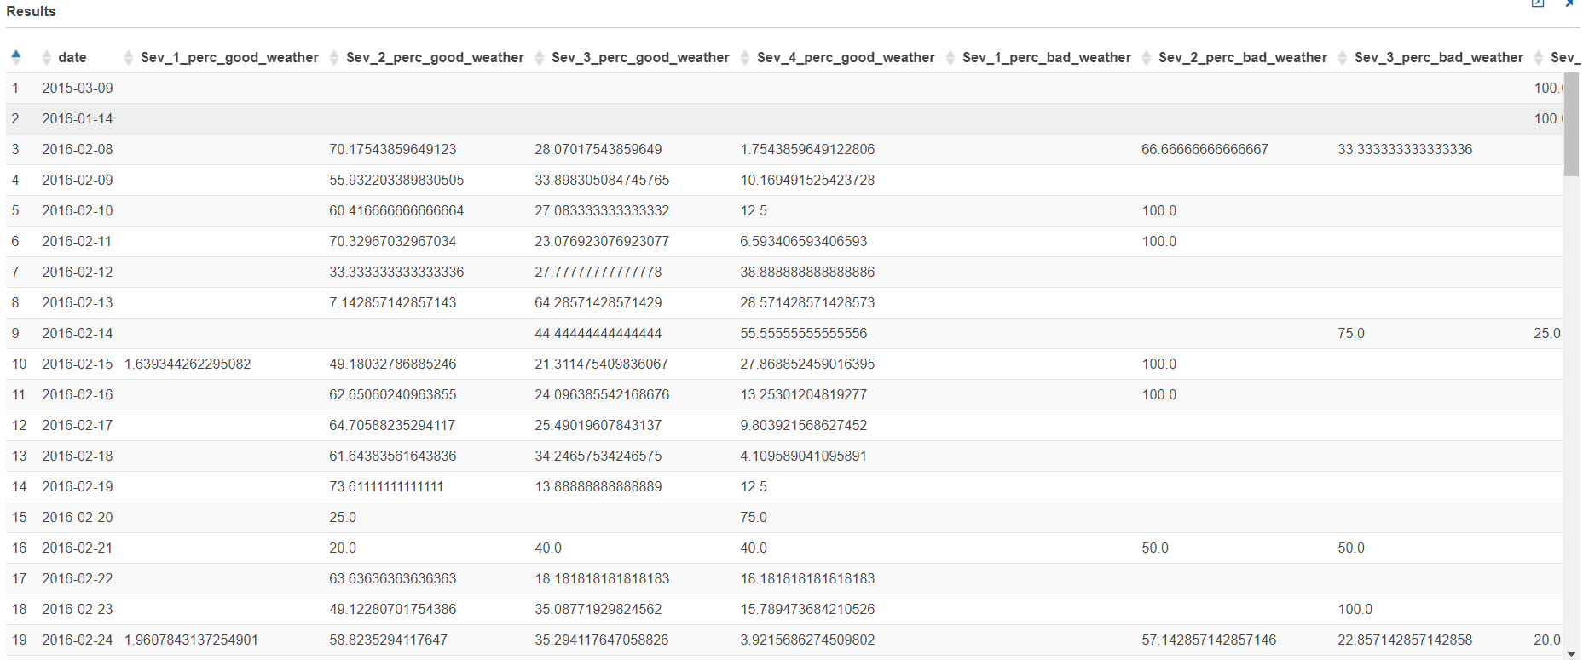

## Query 5

Temperature:

with cte1 as

(select date_format(start_time, '%Y-%m-%d') AS date,severity,weather_condition,

case

when weather_condition = 'Clear' then 'good'

when weather_condition like 'Cloudy%' then 'good'

when weather_condition = 'Drizzle' then 'good'

when weather_condition = 'Drizzle / Windy' then 'good'

when weather_condition like 'Fair%' then 'good'

when weather_condition = 'Haze' then 'good'

when weather_condition like 'Light%' then 'good'

when weather_condition = 'Mist' then 'good'

when weather_condition like 'Mostly%' then 'good'

when weather_condition = 'N/A Precipitation' then 'good'

when weather_condition = 'Overcast' then 'good'

when weather_condition like 'Partial%' then 'good'

when weather_condition like 'Partly%' then 'good'

when weather_condition = 'Patches of Fog' then 'good'

when weather_condition = 'Scattered Clouds' then 'good'

when weather_condition = 'Shallow Fog' then 'good'

when weather_condition = 'Showers in the Vicinity' then 'good'

when weather_condition = 'Small Hail' then 'good'

when weather_condition = 'Thunder in the Vicinity' then 'good'

else 'bad' end as weather_type,

case

when temperature between -80 and -71 then '-80 to -71'

when temperature between -70 and -61 then '-70 to -61'

when temperature between -60 and -51 then '-60 to -51'

when temperature between -50 and -41 then '-50 to -41'

when temperature between -40 and -31 then '-40 to -31'

when temperature between -30 and -21 then '-30 to -21'

when temperature between -20 and -11 then '-20 to -11'

when temperature between -10 and -1 then '-10 to -01'

when temperature between 0 and 9 then '0 to 9'

when temperature between 10 and 19 then '10 to 19'

when temperature between 20 and 29 then '20 to 29'

when temperature between 30 and 39 then '30 to 39'

when temperature between 40 and 49 then '40 to 49'

when temperature between 50 and 59 then '50 to 59'

when temperature between 60 and 69 then '60 to 69'

when temperature between 70 and 79 then '70 to 79'

when temperature between 80 and 89 then '80 to 89'

when temperature between 90 and 99 then '90 to 99'

when temperature between 100 and 109 then '100 to 109'

when temperature between 110 and 119 then '110 to 119'

when temperature between 120 and 129 then '120 to 129'

when temperature between 130 and 139 then '130 to 139'

when temperature between 140 and 149 then '140 to 149'

when temperature between 150 and 159 then '150 to 159'

when temperature between 160 and 169 then '160 to 169'

when temperature between 170 and 179 then '170 to 179'

else 'temperature unknown'

end as temp_range_in_f

from us_accident_v3),

cte2 as

(select *,

case

when severity = 1 and weather_type = 'good' then 'sev1_good'

when severity = 2 and weather_type = 'good' then 'sev2_good'

when severity = 3 and weather_type = 'good' then 'sev3_good'

when severity = 4 and weather_type = 'good' then 'sev4_good'

when severity = 1 and weather_type = 'bad' then 'sev1_bad'

when severity = 2 and weather_type = 'bad' then 'sev2_bad'

when severity = 3 and weather_type = 'bad' then 'sev3_bad'

when severity = 4 and weather_type = 'bad' then 'sev4_bad'

else 'unknown_weather' end as good_bad_sev

from cte1),

cte3 as

(select date,temp_range_in_f,good_bad_sev,count(*) as number_of_accident from cte2 group by date,temp_range_in_f,good_bad_sev

order by date,temp_range_in_f,good_bad_sev asc)

select date,temp_range_in_f, kv1['sev1_good'] as Sev_1_good_weather,

kv2['sev2_good'] as Sev_2_good_weather,

kv3['sev3_good'] as Sev_3_good_weather,

kv4['sev4_good'] as Sev_4_good_weather,

kv5['sev1_bad'] as Sev_1_bad_weather,

kv6['sev2_bad'] as Sev_2_bad_weather,

kv7['sev3_bad'] as Sev_3_bad_weather,

kv8['sev4_bad'] as Sev_4_bad_weather

from (

select date,temp_range_in_f, map_agg(good_bad_sev, number_of_accident) kv1,

map_agg(good_bad_sev, number_of_accident) kv2,

map_agg(good_bad_sev, number_of_accident) kv3,

map_agg(good_bad_sev, number_of_accident) kv4,

map_agg(good_bad_sev, number_of_accident) kv5,

map_agg(good_bad_sev, number_of_accident) kv6,

map_agg(good_bad_sev, number_of_accident) kv7,

map_agg(good_bad_sev, number_of_accident) kv8

from cte3

group by date,temp_range_in_f)

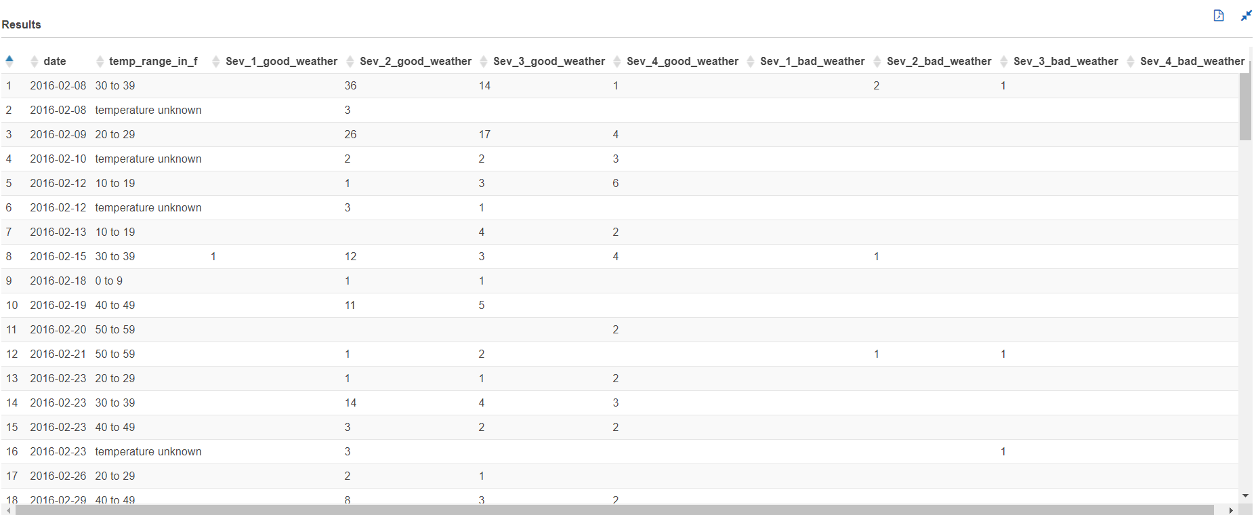

Wind Chill:

with cte1 as

(select date_format(start_time, '%Y-%m-%d') AS date,severity,weather_condition,

case

when weather_condition = 'Clear' then 'good'

when weather_condition like 'Cloudy%' then 'good'

when weather_condition = 'Drizzle' then 'good'

when weather_condition = 'Drizzle / Windy' then 'good'

when weather_condition like 'Fair%' then 'good'

when weather_condition = 'Haze' then 'good'

when weather_condition like 'Light%' then 'good'

when weather_condition = 'Mist' then 'good'

when weather_condition like 'Mostly%' then 'good'

when weather_condition = 'N/A Precipitation' then 'good'

when weather_condition = 'Overcast' then 'good'

when weather_condition like 'Partial%' then 'good'

when weather_condition like 'Partly%' then 'good'

when weather_condition = 'Patches of Fog' then 'good'

when weather_condition = 'Scattered Clouds' then 'good'

when weather_condition = 'Shallow Fog' then 'good'

when weather_condition = 'Showers in the Vicinity' then 'good'

when weather_condition = 'Small Hail' then 'good'

when weather_condition = 'Thunder in the Vicinity' then 'good'

else 'bad' end as weather_type,

case

when wind_chill between -70 and -61 then '-70 to -61'

when wind_chill between -60 and -51 then '-60 to -50'

when wind_chill between -50 and -41 then '-50 to -41'

when wind_chill between -40 and -31 then '-40 to -31'

when wind_chill between -30 and -21 then '-30 to -21'

when wind_chill between -20 and -11 then '-20 to -11'

when wind_chill between -10 and -1 then '-10 to -1'

when wind_chill between 0 and 9 then '0 to 9'

when wind_chill between 10 and 19 then '10 to 19'

when wind_chill between 20 and 29 then '20 to 29'

when wind_chill between 30 and 39 then '30 to 39'

when wind_chill between 40 and 49 then '40 to 49'

when wind_chill between 50 and 59 then '50 to 59'

when wind_chill between 60 and 69 then '60 to 69'

when wind_chill between 70 and 79 then '70 to 79'

when wind_chill between 80 and 89 then '80 to 89'

when wind_chill between 90 and 99 then '90 to 99'

when wind_chill between 100 and 109 then '100 to 109'

when wind_chill between 110 and 119 then '110 to 119'

else 'Unknown Wind_chill'

end

as wind_chill_range

from us_accident_v3),

cte2 as

(select date, severity, weather_condition, weather_type, wind_chill_range,

case

when severity = 1 and weather_type = 'good' then 'sev1_good'

when severity = 2 and weather_type = 'good' then 'sev2_good'

when severity = 3 and weather_type = 'good' then 'sev3_good'

when severity = 4 and weather_type = 'good' then 'sev4_good'

when severity = 1 and weather_type = 'bad' then 'sev1_bad'

when severity = 2 and weather_type = 'bad' then 'sev2_bad'

when severity = 3 and weather_type = 'bad' then 'sev3_bad'

when severity = 4 and weather_type = 'bad' then 'sev4_bad'

else 'unknown_weather' end as good_bad_sev

from cte1),

cte3 as

(select date, wind_chill_range, good_bad_sev, count(*) as number_of_accident from cte2

group by date, wind_chill_range, good_bad_sev

order by date, wind_chill_range, good_bad_sev)

select date,wind_chill_range, kv1['sev1_good'] as Sev_1_count_good_weather,

kv2['sev2_good'] as Sev_2_count_good_weather,

kv3['sev3_good'] as Sev_3_count_good_weather,

kv4['sev4_good'] as Sev_4_count_good_weather,

kv5['sev1_bad'] as Sev_1_count_bad_weather,

kv6['sev2_bad'] as Sev_2_count_bad_weather,

kv7['sev3_bad'] as Sev_3_count_bad_weather,

kv8['sev4_bad'] as Sev_4_count_bad_weather

from (

select date,wind_chill_range, map_agg(good_bad_sev, number_of_accident) kv1,

map_agg(good_bad_sev, number_of_accident) kv2,

map_agg(good_bad_sev, number_of_accident) kv3,

map_agg(good_bad_sev, number_of_accident) kv4,

map_agg(good_bad_sev, number_of_accident) kv5,

map_agg(good_bad_sev, number_of_accident) kv6,

map_agg(good_bad_sev, number_of_accident) kv7,

map_agg(good_bad_sev, number_of_accident) kv8

from cte3

group by date,wind_chill_range

order by date, wind_chill_range)

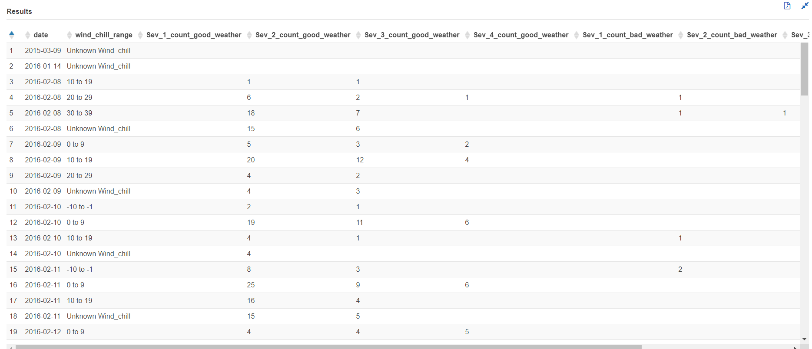

Humidity:

with cte1 as

(select date_format(start_time, '%Y-%m-%d') AS date,severity,weather_condition,

case

when weather_condition = 'Clear' then 'good'

when weather_condition like 'Cloudy%' then 'good'

when weather_condition = 'Drizzle' then 'good'

when weather_condition = 'Drizzle / Windy' then 'good'

when weather_condition like 'Fair%' then 'good'

when weather_condition = 'Haze' then 'good'

when weather_condition like 'Light%' then 'good'

when weather_condition = 'Mist' then 'good'

when weather_condition like 'Mostly%' then 'good'

when weather_condition = 'N/A Precipitation' then 'good'

when weather_condition = 'Overcast' then 'good'

when weather_condition like 'Partial%' then 'good'

when weather_condition like 'Partly%' then 'good'

when weather_condition = 'Patches of Fog' then 'good'

when weather_condition = 'Scattered Clouds' then 'good'

when weather_condition = 'Shallow Fog' then 'good'

when weather_condition = 'Showers in the Vicinity' then 'good'

when weather_condition = 'Small Hail' then 'good'

when weather_condition = 'Thunder in the Vicinity' then 'good'

else 'bad' end as weather_type,

case

when humidity between 1 and 5 then '1 to 5'

when humidity between 6 and 10 then '6 to 10'

when humidity between 11 and 15 then '11 to 15'

when humidity between 16 and 20 then '16 to 20'

when humidity between 21 and 25 then '21 to 25'

when humidity between 26 and 30 then '26 to 30'

when humidity between 31 and 35 then '31 to 35'

when humidity between 36 and 40 then '36 to 40'

when humidity between 41 and 45 then '41 to 45'

when humidity between 46 and 50 then '46 to 50'

when humidity between 51 and 55 then '51 to 55'

when humidity between 56 and 60 then '56 to 60'

when humidity between 61 and 65 then '61 to 65'

when humidity between 66 and 70 then '66 to 70'

when humidity between 71 and 75 then '71 to 75'

when humidity between 76 and 80 then '76 to 80'

when humidity between 81 and 85 then '81 to 85'

when humidity between 86 and 90 then '86 to 90'

when humidity between 91 and 95 then '91 to 95'

when humidity between 96 and 100 then '96 to 100'

else 'Unknown_humidity'

end

as humidity_range

from us_accident_v3),

cte2 as

(select *,

case

when severity = 1 and weather_type = 'good' then 'sev1_good'

when severity = 2 and weather_type = 'good' then 'sev2_good'

when severity = 3 and weather_type = 'good' then 'sev3_good'

when severity = 4 and weather_type = 'good' then 'sev4_good'

when severity = 1 and weather_type = 'bad' then 'sev1_bad'

when severity = 2 and weather_type = 'bad' then 'sev2_bad'

when severity = 3 and weather_type = 'bad' then 'sev3_bad'

when severity = 4 and weather_type = 'bad' then 'sev4_bad'

else 'unknown_weather' end as good_bad_sev

from cte1),

cte3 as

(select date, humidity_range, good_bad_sev, count(*) as number_of_accident from cte2

group by date, humidity_range, good_bad_sev

order by date, humidity_range, good_bad_sev)

select date, humidity_range, kv1['sev1_good'] as Sev_1_count_good_weather,

kv2['sev2_good'] as Sev_2_count_good_weather,

kv3['sev3_good'] as Sev_3_count_good_weather,

kv4['sev4_good'] as Sev_4_count_good_weather,

kv5['sev1_bad'] as Sev_1_count_bad_weather,

kv6['sev2_bad'] as Sev_2_count_bad_weather,

kv7['sev3_bad'] as Sev_3_count_bad_weather,

kv8['sev4_bad'] as Sev_4_count_bad_weather

from (

select date,humidity_range, map_agg(good_bad_sev, number_of_accident) kv1,

map_agg(good_bad_sev, number_of_accident) kv2,

map_agg(good_bad_sev, number_of_accident) kv3,

map_agg(good_bad_sev, number_of_accident) kv4,

map_agg(good_bad_sev, number_of_accident) kv5,

map_agg(good_bad_sev, number_of_accident) kv6,

map_agg(good_bad_sev, number_of_accident) kv7,

map_agg(good_bad_sev, number_of_accident) kv8

from cte3

group by date,humidity_range

order by date, humidity_range)

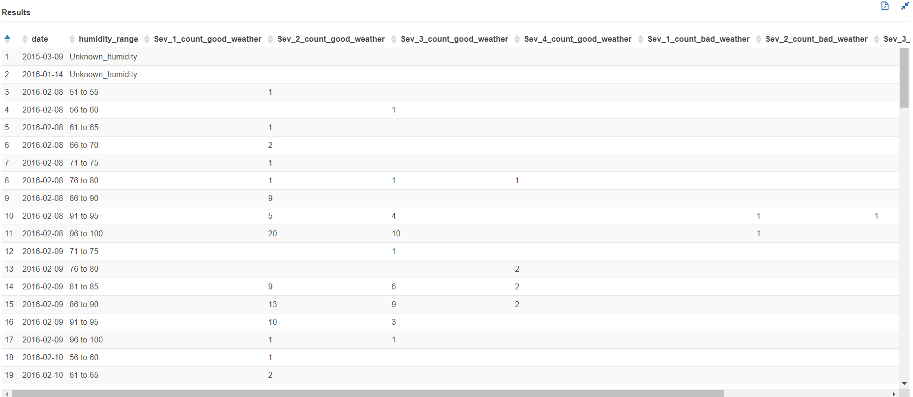

Pressure:

with cte1 as

(select date_format(start_time, '%Y-%m-%d') AS date,severity,weather_condition,

case

when weather_condition = 'Clear' then 'good'

when weather_condition like 'Cloudy%' then 'good'

when weather_condition = 'Drizzle' then 'good'

when weather_condition = 'Drizzle / Windy' then 'good'

when weather_condition like 'Fair%' then 'good'

when weather_condition = 'Haze' then 'good'

when weather_condition like 'Light%' then 'good'

when weather_condition = 'Mist' then 'good'

when weather_condition like 'Mostly%' then 'good'

when weather_condition = 'N/A Precipitation' then 'good'

when weather_condition = 'Overcast' then 'good'

when weather_condition like 'Partial%' then 'good'

when weather_condition like 'Partly%' then 'good'

when weather_condition = 'Patches of Fog' then 'good'

when weather_condition = 'Scattered Clouds' then 'good'

when weather_condition = 'Shallow Fog' then 'good'

when weather_condition = 'Showers in the Vicinity' then 'good'

when weather_condition = 'Small Hail' then 'good'

when weather_condition = 'Thunder in the Vicinity' then 'good'

else 'bad' end as weather_type,

case

when pressure between 0.00 and 3.50 then '0 to 3'

when pressure between 3.51 and 7.50 then '4 to 7'

when pressure between 7.51 and 11.50 then '8 to 11'

when pressure between 11.51 and 15.50 then '12 to 15'

when pressure between 15.51 and 19.50 then '16 to 19'

when pressure between 19.51 and 23.50 then '20 to 23'

when pressure between 23.51 and 27.50 then '24 to 27'

when pressure between 27.51 and 31.50 then '28 to 31'

when pressure between 31.51 and 35.50 then '32 to 35'

else 'pressure unknown'

end as pressure_range

from us_accident_v3),

cte2 as

(select *,

case

when severity = 1 and weather_type = 'good' then 'sev1_good'

when severity = 2 and weather_type = 'good' then 'sev2_good'

when severity = 3 and weather_type = 'good' then 'sev3_good'

when severity = 4 and weather_type = 'good' then 'sev4_good'

when severity = 1 and weather_type = 'bad' then 'sev1_bad'

when severity = 2 and weather_type = 'bad' then 'sev2_bad'

when severity = 3 and weather_type = 'bad' then 'sev3_bad'

when severity = 4 and weather_type = 'bad' then 'sev4_bad'

else 'unknown_weather' end as good_bad_sev

from cte1),

cte3 as

(select date,pressure_range,good_bad_sev,count(*) as number_of_accident from cte2 group by date,pressure_range,good_bad_sev

order by date,pressure_range,good_bad_sev asc)

select date,pressure_range, kv1['sev1_good'] as Sev_1_good_weather,

kv2['sev2_good'] as Sev_2_good_weather,

kv3['sev3_good'] as Sev_3_good_weather,

kv4['sev4_good'] as Sev_4_good_weather,

kv5['sev1_bad'] as Sev_1_bad_weather,

kv6['sev2_bad'] as Sev_2_bad_weather,

kv7['sev3_bad'] as Sev_3_bad_weather,

kv8['sev4_bad'] as Sev_4_bad_weather

from (

select date,pressure_range, map_agg(good_bad_sev, number_of_accident) kv1,

map_agg(good_bad_sev, number_of_accident) kv2,

map_agg(good_bad_sev, number_of_accident) kv3,

map_agg(good_bad_sev, number_of_accident) kv4,

map_agg(good_bad_sev, number_of_accident) kv5,

map_agg(good_bad_sev, number_of_accident) kv6,

map_agg(good_bad_sev, number_of_accident) kv7,

map_agg(good_bad_sev, number_of_accident) kv8

from cte3

group by date,pressure_range)

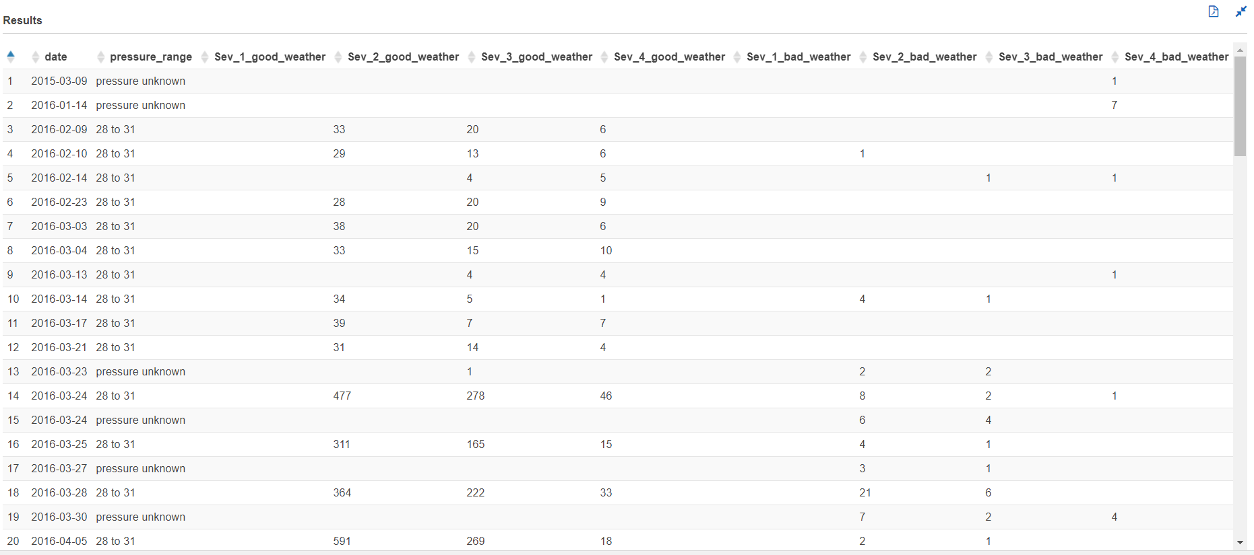

Visibility:

with cte1 as

(select date_format(start_time, '%Y-%m-%d') AS date,severity,weather_condition,

case

when weather_condition = 'Clear' then 'good'

when weather_condition like 'Cloudy%' then 'good'

when weather_condition = 'Drizzle' then 'good'

when weather_condition = 'Drizzle / Windy' then 'good'

when weather_condition like 'Fair%' then 'good'

when weather_condition = 'Haze' then 'good'

when weather_condition like 'Light%' then 'good'

when weather_condition = 'Mist' then 'good'

when weather_condition like 'Mostly%' then 'good'

when weather_condition = 'N/A Precipitation' then 'good'

when weather_condition = 'Overcast' then 'good'

when weather_condition like 'Partial%' then 'good'

when weather_condition like 'Partly%' then 'good'

when weather_condition = 'Patches of Fog' then 'good'

when weather_condition = 'Scattered Clouds' then 'good'

when weather_condition = 'Shallow Fog' then 'good'

when weather_condition = 'Showers in the Vicinity' then 'good'

when weather_condition = 'Small Hail' then 'good'

when weather_condition = 'Thunder in the Vicinity' then 'good'

else 'bad' end as weather_type,

case

when visibility between 0 and 0.06 then '0 to 0.06'

when visibility between 0.6001 and 0.1 then '0.6001 to 0.1'

when visibility between 0.10001 and 0.12 then '0.10001 to 0.12'

when visibility between 0.12001 and 0.19 then '0.12001 to 0.19'

when visibility between 0.19001 and 0.25 then '0.19001 to 0.25'

when visibility between 0.25001 and 0.30 then '0.25001 to 0.30'

when visibility between 0.30001 and 0.38 then '0.30001 to 0.38'

when visibility between 0.38001 and 0.4 then '0.38001 to 0.4'

when visibility between 0.40001 and 0.5 then '0.40001 to 0.5'

when visibility between 0.50001 and 0.6 then '0.50001 to 0.6'

when visibility between 0.60001 and 0.7 then '0.60001 to 0.7'

when visibility between 0.70001 and 0.8 then '0.70001 to 0.8'

when visibility between 0.80001 and 0.9 then '0.80001 to 0.9'

when visibility between 0.90001 and 1.0 then '0.90001 to 1.0'

when visibility between 1.00001 and 1.2 then '1.00001 to 1.2'

when visibility between 1.20001 and 1.4 then '1.20001 to 1.4'

when visibility between 1.40001 and 10 then '1.40001 to 10'

when visibility between 10.0001 and 50 then '10.0001 to 50'

when visibility between 50.00001 and 150 then '50.00001 to 150'

else 'visibility unknown'

end as visibility_range

from us_accident_v3),

cte2 as

(select *,

case

when severity = 1 and weather_type = 'good' then 'sev1_good'

when severity = 2 and weather_type = 'good' then 'sev2_good'

when severity = 3 and weather_type = 'good' then 'sev3_good'

when severity = 4 and weather_type = 'good' then 'sev4_good'

when severity = 1 and weather_type = 'bad' then 'sev1_bad'

when severity = 2 and weather_type = 'bad' then 'sev2_bad'

when severity = 3 and weather_type = 'bad' then 'sev3_bad'

when severity = 4 and weather_type = 'bad' then 'sev4_bad'

else 'unknown_weather' end as good_bad_sev

from cte1),

cte3 as

(select date,visibility_range,good_bad_sev,count(*) as number_of_accident from cte2 group by date,visibility_range,good_bad_sev

order by date,visibility_range,good_bad_sev asc)

select date,visibility_range, kv1['sev1_good'] as Sev_1_good_weather,

kv2['sev2_good'] as Sev_2_good_weather,

kv3['sev3_good'] as Sev_3_good_weather,

kv4['sev4_good'] as Sev_4_good_weather,

kv5['sev1_bad'] as Sev_1_bad_weather,

kv6['sev2_bad'] as Sev_2_bad_weather,

kv7['sev3_bad'] as Sev_3_bad_weather,

kv8['sev4_bad'] as Sev_4_bad_weather

from (

select date,visibility_range, map_agg(good_bad_sev, number_of_accident) kv1,

map_agg(good_bad_sev, number_of_accident) kv2,

map_agg(good_bad_sev, number_of_accident) kv3,

map_agg(good_bad_sev, number_of_accident) kv4,

map_agg(good_bad_sev, number_of_accident) kv5,

map_agg(good_bad_sev, number_of_accident) kv6,

map_agg(good_bad_sev, number_of_accident) kv7,

map_agg(good_bad_sev, number_of_accident) kv8

from cte3

group by date,visibility_range)

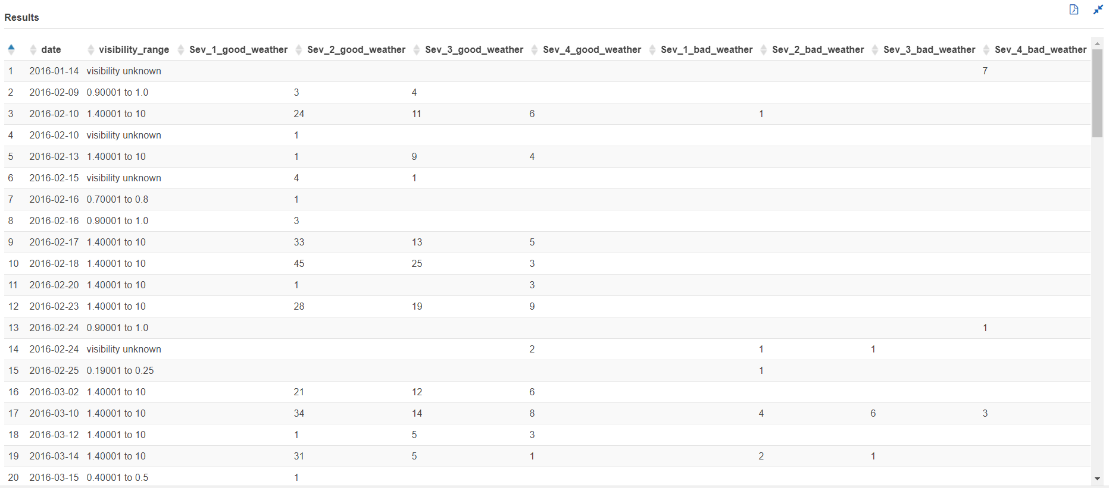

Precipitation:

with cte1 as

(select date_format(start_time, '%Y-%m-%d') AS date,severity,weather_condition,

case

when weather_condition = 'Clear' then 'good'

when weather_condition like 'Cloudy%' then 'good'

when weather_condition = 'Drizzle' then 'good'

when weather_condition = 'Drizzle / Windy' then 'good'

when weather_condition like 'Fair%' then 'good'

when weather_condition = 'Haze' then 'good'

when weather_condition like 'Light%' then 'good'

when weather_condition = 'Mist' then 'good'

when weather_condition like 'Mostly%' then 'good'

when weather_condition = 'N/A Precipitation' then 'good'

when weather_condition = 'Overcast' then 'good'

when weather_condition like 'Partial%' then 'good'

when weather_condition like 'Partly%' then 'good'

when weather_condition = 'Patches of Fog' then 'good'

when weather_condition = 'Scattered Clouds' then 'good'

when weather_condition = 'Shallow Fog' then 'good'

when weather_condition = 'Showers in the Vicinity' then 'good'

when weather_condition = 'Small Hail' then 'good'

when weather_condition = 'Thunder in the Vicinity' then 'good'

else 'bad' end as weather_type,

case

when precipitation between 0 and 1 then '0 to 1'

when precipitation between 1.00001 and 2 then '1.00001 to 2'

when precipitation between 2.00001 and 3 then '2.00001 to 3'

when precipitation between 3.00001 and 4 then '3.00001 to 4'

when precipitation between 4.00001 and 5 then '4.00001 to 5'

when precipitation between 5.00001 and 6 then '5.00001 to 6'

when precipitation between 6.00001 and 7 then '6.00001 to 7'

when precipitation between 7.00001 and 8 then '7.00001 to 8'

when precipitation between 8.00001 and 9 then '8.00001 to 9'

when precipitation between 9.00001 and 10 then '9.00001 to 10'

when precipitation between 10.00001 and 11 then '10.00001 to 11'

when precipitation between 11.00001 and 12 then '11.00001 to 12'

when precipitation between 12.00001 and 13 then '12.00001 to 13'

when precipitation between 13.00001 and 14 then '13.00001 to 14'

when precipitation between 14.00001 and 15 then '14.00001 to 15'

when precipitation between 15.00001 and 16 then '15.00001 to 16'

when precipitation between 16.00001 and 17 then '16.00001 to 17'

when precipitation between 17.00001 and 18 then '17.00001 to 18'

when precipitation between 18.00001 and 19 then '18.00001 to 19'

when precipitation between 19.00001 and 20 then '19.00001 to 20'

when precipitation between 20.00001 and 21 then '20.00001 to 21'

when precipitation between 21.00001 and 22 then '21.00001 to 22'

when precipitation between 22.00001 and 23 then '22.00001 to 23'

when precipitation between 23.00001 and 24 then '23.00001 to 24'

when precipitation between 24.00001 and 25 then '24.00001 to 25'

else 'precipitation unknown'

end as precipitation_range

from us_accident_v3),

cte2 as

(select *,

case

when severity = 1 and weather_type = 'good' then 'sev1_good'

when severity = 2 and weather_type = 'good' then 'sev2_good'

when severity = 3 and weather_type = 'good' then 'sev3_good'

when severity = 4 and weather_type = 'good' then 'sev4_good'

when severity = 1 and weather_type = 'bad' then 'sev1_bad'

when severity = 2 and weather_type = 'bad' then 'sev2_bad'

when severity = 3 and weather_type = 'bad' then 'sev3_bad'

when severity = 4 and weather_type = 'bad' then 'sev4_bad'

else 'unknown_weather' end as good_bad_sev

from cte1),

cte3 as

(select date,precipitation_range,good_bad_sev,count(*) as number_of_accident from cte2 group by date,precipitation_range,good_bad_sev

order by date,precipitation_range,good_bad_sev asc)

select date,precipitation_range, kv1['sev1_good'] as Sev_1_good_weather,

kv2['sev2_good'] as Sev_2_good_weather,

kv3['sev3_good'] as Sev_3_good_weather,

kv4['sev4_good'] as Sev_4_good_weather,

kv5['sev1_bad'] as Sev_1_bad_weather,

kv6['sev2_bad'] as Sev_2_bad_weather,

kv7['sev3_bad'] as Sev_3_bad_weather,

kv8['sev4_bad'] as Sev_4_bad_weather

from (

select date,precipitation_range, map_agg(good_bad_sev, number_of_accident) kv1,

map_agg(good_bad_sev, number_of_accident) kv2,

map_agg(good_bad_sev, number_of_accident) kv3,

map_agg(good_bad_sev, number_of_accident) kv4,

map_agg(good_bad_sev, number_of_accident) kv5,

map_agg(good_bad_sev, number_of_accident) kv6,

map_agg(good_bad_sev, number_of_accident) kv7,

map_agg(good_bad_sev, number_of_accident) kv8

from cte3

group by date,precipitation_range)

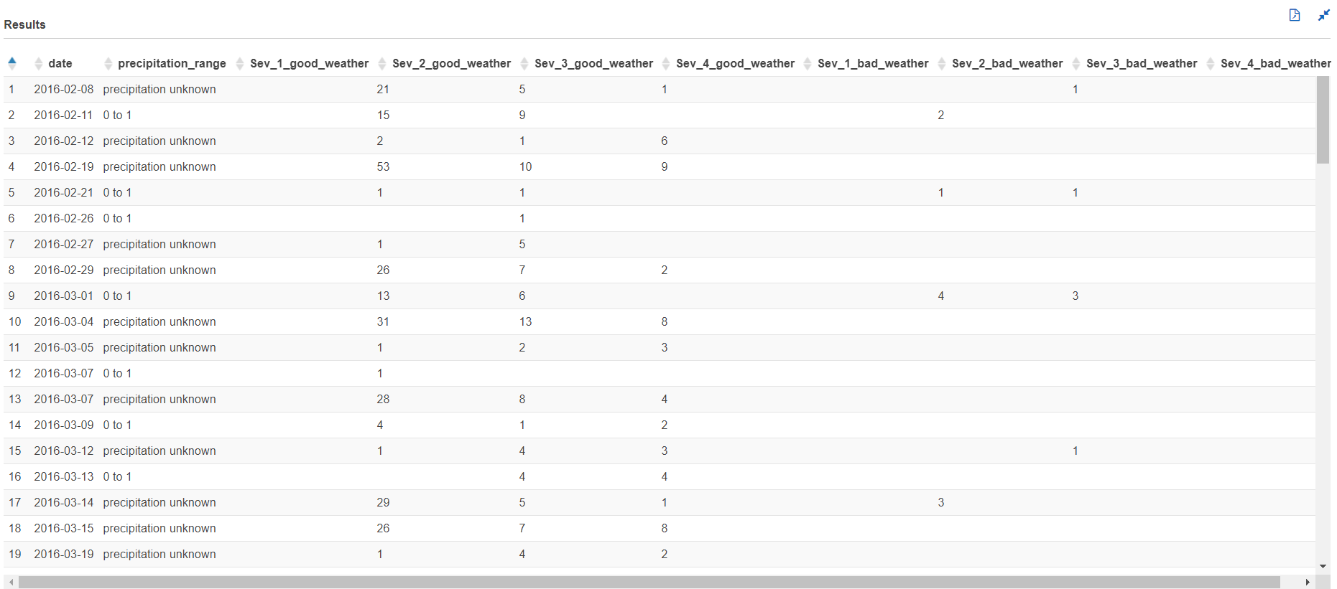

Wind Speed:

with cte1 as

(select date_format(start_time, '%Y-%m-%d') AS date,severity,weather_condition,

case

when weather_condition = 'Clear' then 'good'

when weather_condition like 'Cloudy%' then 'good'

when weather_condition = 'Drizzle' then 'good'

when weather_condition = 'Drizzle / Windy' then 'good'

when weather_condition like 'Fair%' then 'good'

when weather_condition = 'Haze' then 'good'

when weather_condition like 'Light%' then 'good'

when weather_condition = 'Mist' then 'good'

when weather_condition like 'Mostly%' then 'good'

when weather_condition = 'N/A Precipitation' then 'good'

when weather_condition = 'Overcast' then 'good'

when weather_condition like 'Partial%' then 'good'

when weather_condition like 'Partly%' then 'good'

when weather_condition = 'Patches of Fog' then 'good'

when weather_condition = 'Scattered Clouds' then 'good'

when weather_condition = 'Shallow Fog' then 'good'

when weather_condition = 'Showers in the Vicinity' then 'good'

when weather_condition = 'Small Hail' then 'good'

when weather_condition = 'Thunder in the Vicinity' then 'good'

else 'bad' end as weather_type,

case

when wind_speed between 0 and 1 then '0 to 1'

when wind_speed between 1.00001 and 2 then '1.00001 to 2'

when wind_speed between 2.00001 and 3 then '2.00001 to 3'

when wind_speed between 3.00001 and 4 then '3.00001 to 4'

when wind_speed between 4.00001 and 5 then '4.00001 to 5'

when wind_speed between 5.00001 and 6 then '5.00001 to 6'

when wind_speed between 6.00001 and 7 then '6.00001 to 7'

when wind_speed between 7.00001 and 8 then '7.00001 to 8'

when wind_speed between 8.00001 and 9 then '8.00001 to 9'

when wind_speed between 9.00001 and 10 then '9.00001 to 10'

when wind_speed between 10.00001 and 11 then '10.00001 to 11'

when wind_speed between 11.00001 and 12 then '11.00001 to 12'

when wind_speed between 12.00001 and 13 then '12.00001 to 13'

when wind_speed between 13.00001 and 14 then '13.00001 to 14'

when wind_speed between 14.00001 and 15 then '14.00001 to 15'

when wind_speed between 15.00001 and 16 then '15.00001 to 16'

when wind_speed between 16.00001 and 17 then '16.00001 to 17'

when wind_speed between 17.00001 and 18 then '17.00001 to 18'

when wind_speed between 18.00001 and 19 then '18.00001 to 19'

when wind_speed between 19.00001 and 20 then '19.00001 to 20'

when wind_speed between 20.00001 and 21 then '20.00001 to 21'

when wind_speed between 21.00001 and 22 then '21.00001 to 22'

when wind_speed between 22.00001 and 23 then '22.00001 to 23'

when wind_speed between 23.00001 and 24 then '23.00001 to 24'

when wind_speed between 24.00001 and 25 then '24.00001 to 25'

when wind_speed between 25.00001 and 26 then '25.00001 to 26'

when wind_speed between 26.00001 and 27 then '26.00001 to 27'

when wind_speed between 27.00001 and 28 then '27.00001 to 28'

when wind_speed between 28.00001 and 29 then '28.00001 to 29'

when wind_speed between 29.00001 and 30 then '29.00001 to 30'

when wind_speed between 30.00001 and 31 then '30.00001 to 31'

when wind_speed between 31.00001 and 32 then '31.00001 to 32'

when wind_speed between 32.00001 and 33 then '32.00001 to 33'

when wind_speed between 33.00001 and 34 then '33.00001 to 34'

when wind_speed between 34.00001 and 35 then '34.00001 to 35'

when wind_speed between 35.00001 and 36 then '35.00001 to 36'

when wind_speed between 36.00001 and 37 then '36.00001 to 37'

when wind_speed between 37.00001 and 38 then '37.00001 to 38'

when wind_speed between 38.00001 and 39 then '38.00001 to 39'

when wind_speed between 39.00001 and 40 then '39.00001 to 40'

when wind_speed between 40.00001 and 41 then '40.00001 to 41'

when wind_speed between 41.00001 and 42 then '41.00001 to 42'

when wind_speed between 42.00001 and 43 then '42.00001 to 43'

when wind_speed >= 43.00001 then 'above 43.00001'

else 'wind speed unknown'

end as wind_speed_range

from us_accident_v3),

cte2 as

(select *,

case

when severity = 1 and weather_type = 'good' then 'sev1_good'

when severity = 2 and weather_type = 'good' then 'sev2_good'

when severity = 3 and weather_type = 'good' then 'sev3_good'

when severity = 4 and weather_type = 'good' then 'sev4_good'

when severity = 1 and weather_type = 'bad' then 'sev1_bad'

when severity = 2 and weather_type = 'bad' then 'sev2_bad'

when severity = 3 and weather_type = 'bad' then 'sev3_bad'

when severity = 4 and weather_type = 'bad' then 'sev4_bad'

else 'unknown_weather' end as good_bad_sev

from cte1),

cte3 as

(select date,wind_speed_range,good_bad_sev,count(*) as number_of_accident from cte2 group by date,wind_speed_range,good_bad_sev

order by date,wind_speed_range,good_bad_sev asc)

select date,wind_speed_range, kv1['sev1_good'] as Sev_1_good_weather,

kv2['sev2_good'] as Sev_2_good_weather,

kv3['sev3_good'] as Sev_3_good_weather,

kv4['sev4_good'] as Sev_4_good_weather,

kv5['sev1_bad'] as Sev_1_bad_weather,

kv6['sev2_bad'] as Sev_2_bad_weather,

kv7['sev3_bad'] as Sev_3_bad_weather,

kv8['sev4_bad'] as Sev_4_bad_weather

from (

select date,wind_speed_range, map_agg(good_bad_sev, number_of_accident) kv1,

map_agg(good_bad_sev, number_of_accident) kv2,

map_agg(good_bad_sev, number_of_accident) kv3,

map_agg(good_bad_sev, number_of_accident) kv4,

map_agg(good_bad_sev, number_of_accident) kv5,

map_agg(good_bad_sev, number_of_accident) kv6,

map_agg(good_bad_sev, number_of_accident) kv7,

map_agg(good_bad_sev, number_of_accident) kv8

from cte3

group by date,wind_speed_range)

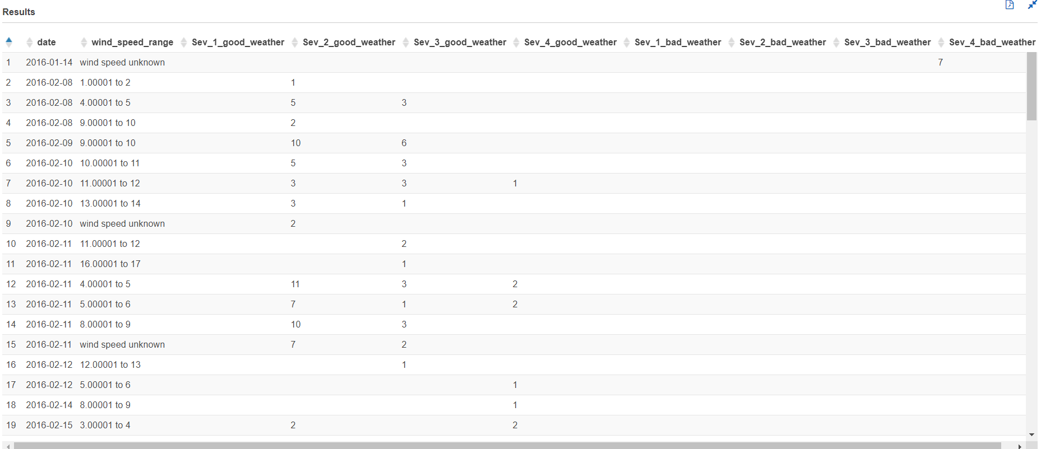

Crossing:

with cte1 as

(select date_format(start_time, '%Y-%m-%d') AS date,severity,weather_condition,crossing,

case

when weather_condition = 'Clear' then 'good'

when weather_condition like 'Cloudy%' then 'good'

when weather_condition = 'Drizzle' then 'good'

when weather_condition = 'Drizzle / Windy' then 'good'

when weather_condition like 'Fair%' then 'good'

when weather_condition = 'Haze' then 'good'

when weather_condition like 'Light%' then 'good'

when weather_condition = 'Mist' then 'good'

when weather_condition like 'Mostly%' then 'good'

when weather_condition = 'N/A Precipitation' then 'good'

when weather_condition = 'Overcast' then 'good'

when weather_condition like 'Partial%' then 'good'

when weather_condition like 'Partly%' then 'good'

when weather_condition = 'Patches of Fog' then 'good'

when weather_condition = 'Scattered Clouds' then 'good'

when weather_condition = 'Shallow Fog' then 'good'

when weather_condition = 'Showers in the Vicinity' then 'good'

when weather_condition = 'Small Hail' then 'good'

when weather_condition = 'Thunder in the Vicinity' then 'good'

else 'bad' end as weather_type

from us_accident_v3),

cte2 as

(select *,

case

when severity = 1 and weather_type = 'good' then 'sev1_good'

when severity = 2 and weather_type = 'good' then 'sev2_good'

when severity = 3 and weather_type = 'good' then 'sev3_good'

when severity = 4 and weather_type = 'good' then 'sev4_good'

when severity = 1 and weather_type = 'bad' then 'sev1_bad'

when severity = 2 and weather_type = 'bad' then 'sev2_bad'

when severity = 3 and weather_type = 'bad' then 'sev3_bad'

when severity = 4 and weather_type = 'bad' then 'sev4_bad'

else 'unknown_weather' end as good_bad_sev

from cte1),

cte3 as

(select date,crossing,good_bad_sev,count(*) as number_of_accident from cte2 group by date,crossing,good_bad_sev

order by date asc)

select date,crossing, kv1['sev1_good'] as Sev_1_good_weather,

kv2['sev2_good'] as Sev_2_good_weather,

kv3['sev3_good'] as Sev_3_good_weather,

kv4['sev1_good'] as Sev_4_good_weather,

kv5['sev1_bad'] as Sev_1_bad_weather,

kv6['sev2_bad'] as Sev_2_bad_weather,

kv7['sev3_bad'] as Sev_3_bad_weather,

kv8['sev4_bad'] as Sev_4_bad_weather

from (

select date,crossing, map_agg(good_bad_sev, number_of_accident) kv1,

map_agg(good_bad_sev, number_of_accident) kv2,

map_agg(good_bad_sev, number_of_accident) kv3,

map_agg(good_bad_sev, number_of_accident) kv4,

map_agg(good_bad_sev, number_of_accident) kv5,

map_agg(good_bad_sev, number_of_accident) kv6,

map_agg(good_bad_sev, number_of_accident) kv7,

map_agg(good_bad_sev, number_of_accident) kv8

from cte3

group by date,crossing)

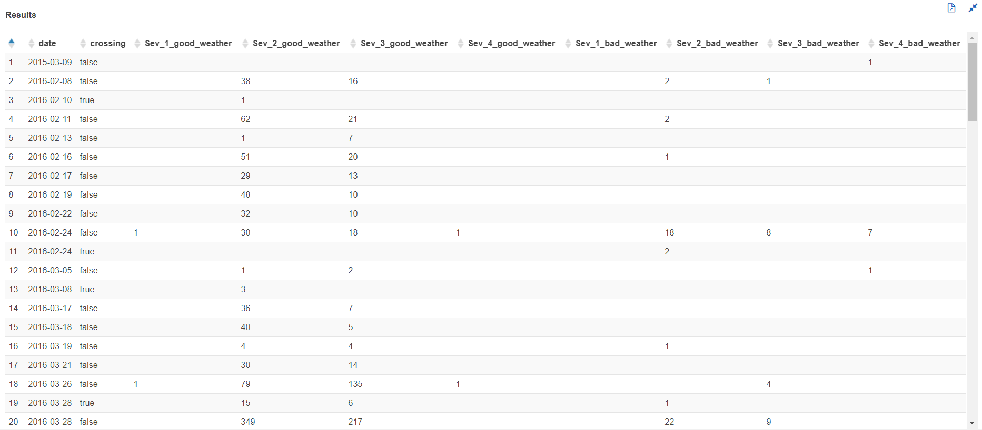

Give_way:

with cte1 as

(select date_format(start_time, '%Y-%m-%d') AS date,severity,weather_condition,give_way,

case

when weather_condition = 'Clear' then 'good'

when weather_condition like 'Cloudy%' then 'good'

when weather_condition = 'Drizzle' then 'good'

when weather_condition = 'Drizzle / Windy' then 'good'

when weather_condition like 'Fair%' then 'good'

when weather_condition = 'Haze' then 'good'

when weather_condition like 'Light%' then 'good'

when weather_condition = 'Mist' then 'good'

when weather_condition like 'Mostly%' then 'good'

when weather_condition = 'N/A Precipitation' then 'good'

when weather_condition = 'Overcast' then 'good'

when weather_condition like 'Partial%' then 'good'

when weather_condition like 'Partly%' then 'good'

when weather_condition = 'Patches of Fog' then 'good'

when weather_condition = 'Scattered Clouds' then 'good'

when weather_condition = 'Shallow Fog' then 'good'

when weather_condition = 'Showers in the Vicinity' then 'good'

when weather_condition = 'Small Hail' then 'good'

when weather_condition = 'Thunder in the Vicinity' then 'good'

else 'bad' end as weather_type

from us_accident_v3),

cte2 as

(select *,

case

when severity = 1 and weather_type = 'good' then 'sev1_good'

when severity = 2 and weather_type = 'good' then 'sev2_good'

when severity = 3 and weather_type = 'good' then 'sev3_good'

when severity = 4 and weather_type = 'good' then 'sev4_good'

when severity = 1 and weather_type = 'bad' then 'sev1_bad'

when severity = 2 and weather_type = 'bad' then 'sev2_bad'

when severity = 3 and weather_type = 'bad' then 'sev3_bad'

when severity = 4 and weather_type = 'bad' then 'sev4_bad'

else 'unknown_weather' end as good_bad_sev

from cte1),

cte3 as

(select date,give_way,good_bad_sev,count(*) as number_of_accident from cte2 group by date,give_way,good_bad_sev

order by date asc)

select date,give_way,kv1['sev1_good'] as Sev_1_good_weather,

kv2['sev2_good'] as Sev_2_good_weather,

kv3['sev3_good'] as Sev_3_good_weather,

kv4['sev1_good'] as Sev_4_good_weather,

kv5['sev1_bad'] as Sev_1_bad_weather,

kv6['sev2_bad'] as Sev_2_bad_weather,

kv7['sev3_bad'] as Sev_3_bad_weather,

kv8['sev4_bad'] as Sev_4_bad_weather

from (

select date,give_way,map_agg(good_bad_sev, number_of_accident) kv1,

map_agg(good_bad_sev, number_of_accident) kv2,

map_agg(good_bad_sev, number_of_accident) kv3,

map_agg(good_bad_sev, number_of_accident) kv4,

map_agg(good_bad_sev, number_of_accident) kv5,

map_agg(good_bad_sev, number_of_accident) kv6,

map_agg(good_bad_sev, number_of_accident) kv7,

map_agg(good_bad_sev, number_of_accident) kv8

from cte3

group by date,give_way)

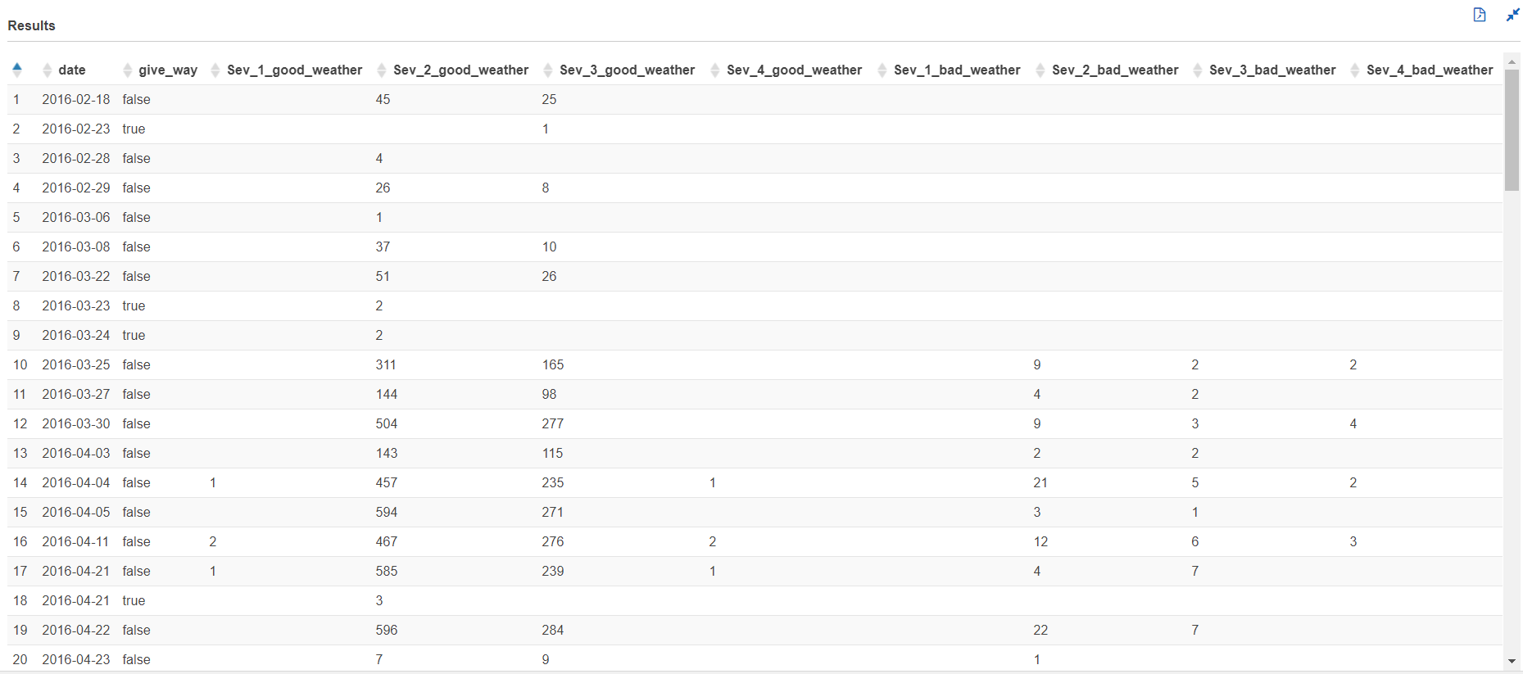

Junction:

with cte1 as

(select date_format(start_time, '%Y-%m-%d') AS date,severity,weather_condition,junction,

case

when weather_condition = 'Clear' then 'good'

when weather_condition like 'Cloudy%' then 'good'

when weather_condition = 'Drizzle' then 'good'

when weather_condition = 'Drizzle / Windy' then 'good'

when weather_condition like 'Fair%' then 'good'

when weather_condition = 'Haze' then 'good'

when weather_condition like 'Light%' then 'good'

when weather_condition = 'Mist' then 'good'

when weather_condition like 'Mostly%' then 'good'

when weather_condition = 'N/A Precipitation' then 'good'

when weather_condition = 'Overcast' then 'good'

when weather_condition like 'Partial%' then 'good'

when weather_condition like 'Partly%' then 'good'

when weather_condition = 'Patches of Fog' then 'good'

when weather_condition = 'Scattered Clouds' then 'good'

when weather_condition = 'Shallow Fog' then 'good'

when weather_condition = 'Showers in the Vicinity' then 'good'

when weather_condition = 'Small Hail' then 'good'

when weather_condition = 'Thunder in the Vicinity' then 'good'

else 'bad' end as weather_type

from us_accident_v3),

cte2 as

(select *,

case

when severity = 1 and weather_type = 'good' then 'sev1_good'

when severity = 2 and weather_type = 'good' then 'sev2_good'

when severity = 3 and weather_type = 'good' then 'sev3_good'

when severity = 4 and weather_type = 'good' then 'sev4_good'

when severity = 1 and weather_type = 'bad' then 'sev1_bad'

when severity = 2 and weather_type = 'bad' then 'sev2_bad'

when severity = 3 and weather_type = 'bad' then 'sev3_bad'

when severity = 4 and weather_type = 'bad' then 'sev4_bad'

else 'unknown_weather' end as good_bad_sev

from cte1),

cte3 as

(select date,junction,good_bad_sev,count(*) as number_of_accident from cte2 group by date,junction,good_bad_sev

order by date asc)

select date,junction,kv1['sev1_good'] as Sev_1_good_weather,

kv2['sev2_good'] as Sev_2_good_weather,

kv3['sev3_good'] as Sev_3_good_weather,

kv4['sev1_good'] as Sev_4_good_weather,

kv5['sev1_bad'] as Sev_1_bad_weather,

kv6['sev2_bad'] as Sev_2_bad_weather,

kv7['sev3_bad'] as Sev_3_bad_weather,

kv8['sev4_bad'] as Sev_4_bad_weather

from (

select date,junction,map_agg(good_bad_sev, number_of_accident) kv1,

map_agg(good_bad_sev, number_of_accident) kv2,

map_agg(good_bad_sev, number_of_accident) kv3,

map_agg(good_bad_sev, number_of_accident) kv4,

map_agg(good_bad_sev, number_of_accident) kv5,

map_agg(good_bad_sev, number_of_accident) kv6,

map_agg(good_bad_sev, number_of_accident) kv7,

map_agg(good_bad_sev, number_of_accident) kv8

from cte3

group by date,junction)

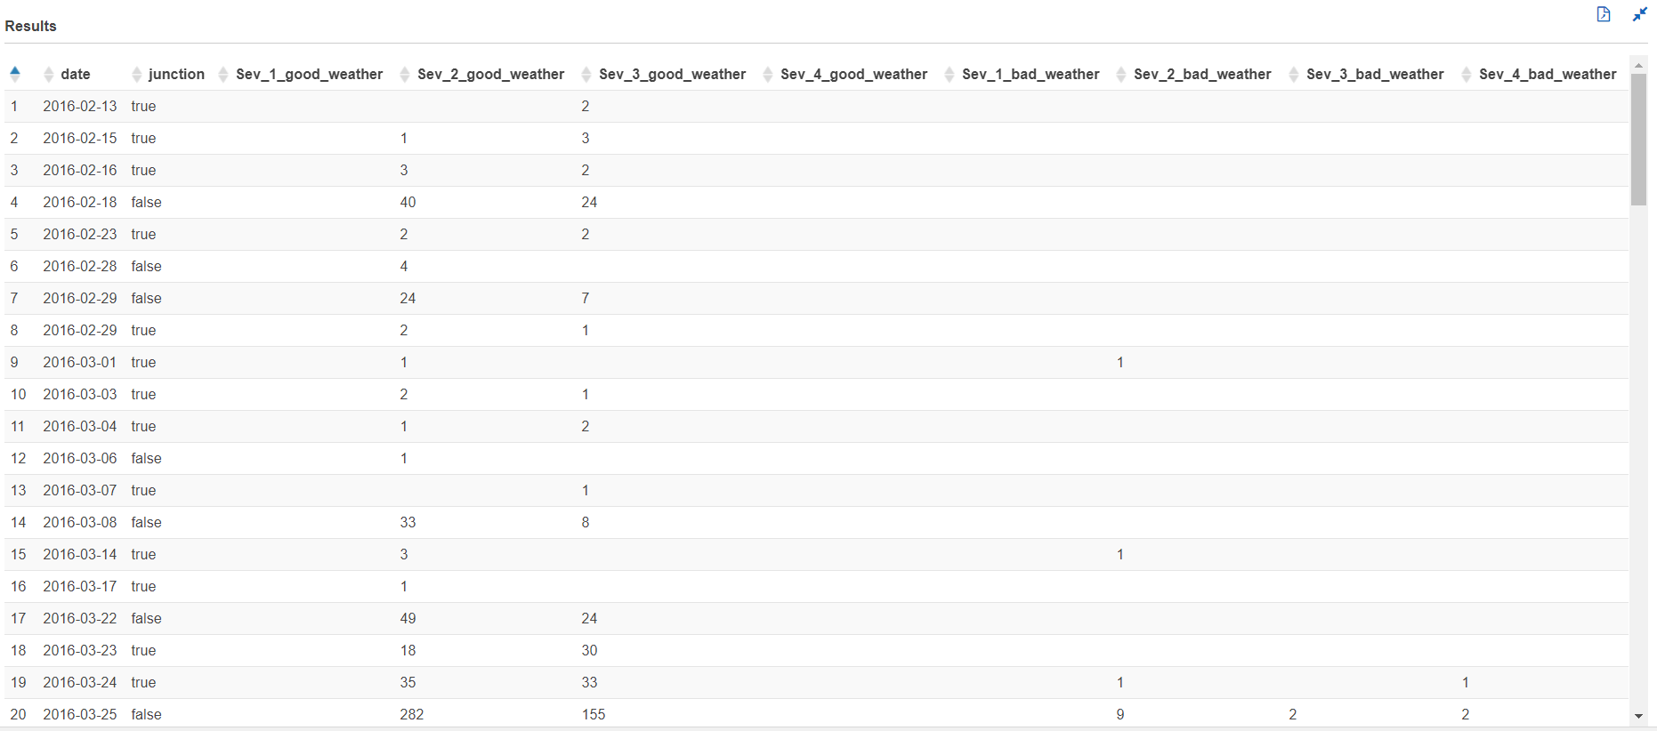

No_exit:

with cte1 as

(select date_format(start_time, '%Y-%m-%d') AS date,severity,weather_condition,no_exit,

case

when weather_condition = 'Clear' then 'good'

when weather_condition like 'Cloudy%' then 'good'

when weather_condition = 'Drizzle' then 'good'

when weather_condition = 'Drizzle / Windy' then 'good'

when weather_condition like 'Fair%' then 'good'

when weather_condition = 'Haze' then 'good'

when weather_condition like 'Light%' then 'good'

when weather_condition = 'Mist' then 'good'

when weather_condition like 'Mostly%' then 'good'

when weather_condition = 'N/A Precipitation' then 'good'

when weather_condition = 'Overcast' then 'good'

when weather_condition like 'Partial%' then 'good'

when weather_condition like 'Partly%' then 'good'

when weather_condition = 'Patches of Fog' then 'good'

when weather_condition = 'Scattered Clouds' then 'good'

when weather_condition = 'Shallow Fog' then 'good'

when weather_condition = 'Showers in the Vicinity' then 'good'

when weather_condition = 'Small Hail' then 'good'

when weather_condition = 'Thunder in the Vicinity' then 'good'

else 'bad' end as weather_type

from us_accident_v3),

cte2 as

(select *,

case

when severity = 1 and weather_type = 'good' then 'sev1_good'

when severity = 2 and weather_type = 'good' then 'sev2_good'

when severity = 3 and weather_type = 'good' then 'sev3_good'

when severity = 4 and weather_type = 'good' then 'sev4_good'

when severity = 1 and weather_type = 'bad' then 'sev1_bad'

when severity = 2 and weather_type = 'bad' then 'sev2_bad'

when severity = 3 and weather_type = 'bad' then 'sev3_bad'

when severity = 4 and weather_type = 'bad' then 'sev4_bad'

else 'unknown_weather' end as good_bad_sev

from cte1),

cte3 as

(select date,no_exit,good_bad_sev,count(*) as number_of_accident from cte2 group by date,no_exit,good_bad_sev

order by date asc)

select date,no_exit,kv1['sev1_good'] as Sev_1_good_weather,

kv2['sev2_good'] as Sev_2_good_weather,

kv3['sev3_good'] as Sev_3_good_weather,

kv4['sev1_good'] as Sev_4_good_weather,

kv5['sev1_bad'] as Sev_1_bad_weather,

kv6['sev2_bad'] as Sev_2_bad_weather,

kv7['sev3_bad'] as Sev_3_bad_weather,

kv8['sev4_bad'] as Sev_4_bad_weather

from (

select date,no_exit,map_agg(good_bad_sev, number_of_accident) kv1,

map_agg(good_bad_sev, number_of_accident) kv2,

map_agg(good_bad_sev, number_of_accident) kv3,

map_agg(good_bad_sev, number_of_accident) kv4,

map_agg(good_bad_sev, number_of_accident) kv5,

map_agg(good_bad_sev, number_of_accident) kv6,

map_agg(good_bad_sev, number_of_accident) kv7,

map_agg(good_bad_sev, number_of_accident) kv8

from cte3

group by date,no_exit)

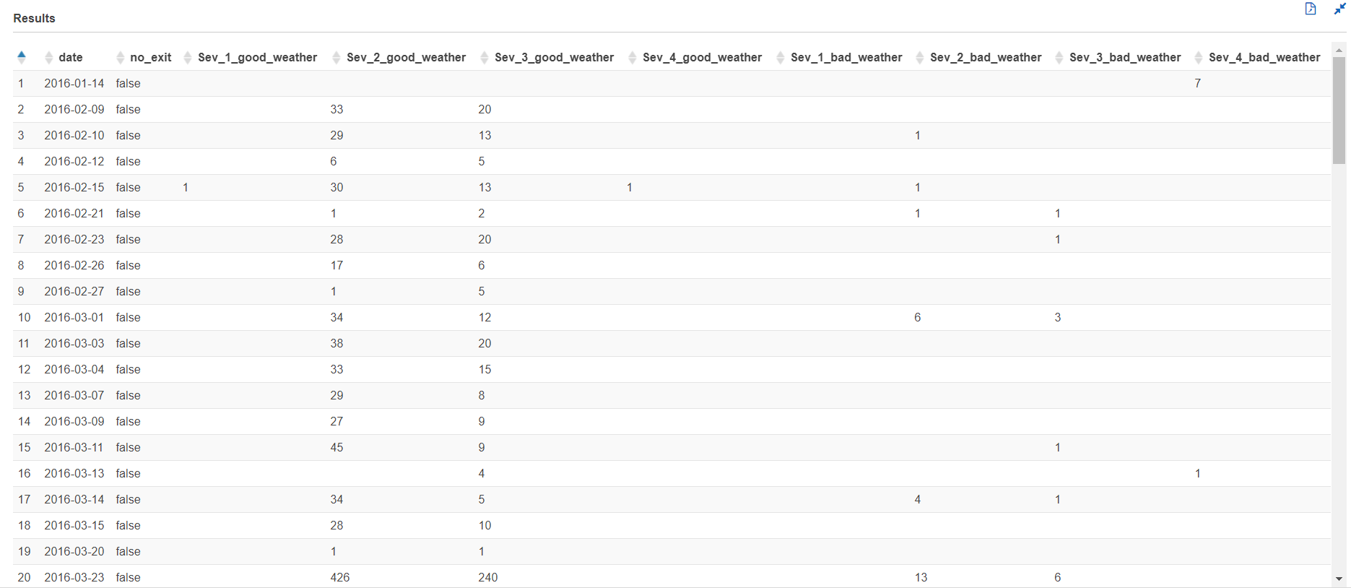

Roundabout:

with cte1 as

(select date_format(start_time, '%Y-%m-%d') AS date,severity,weather_condition,roundabout,

case

when weather_condition = 'Clear' then 'good'

when weather_condition like 'Cloudy%' then 'good'

when weather_condition = 'Drizzle' then 'good'

when weather_condition = 'Drizzle / Windy' then 'good'

when weather_condition like 'Fair%' then 'good'

when weather_condition = 'Haze' then 'good'

when weather_condition like 'Light%' then 'good'

when weather_condition = 'Mist' then 'good'

when weather_condition like 'Mostly%' then 'good'

when weather_condition = 'N/A Precipitation' then 'good'

when weather_condition = 'Overcast' then 'good'

when weather_condition like 'Partial%' then 'good'

when weather_condition like 'Partly%' then 'good'

when weather_condition = 'Patches of Fog' then 'good'

when weather_condition = 'Scattered Clouds' then 'good'

when weather_condition = 'Shallow Fog' then 'good'

when weather_condition = 'Showers in the Vicinity' then 'good'

when weather_condition = 'Small Hail' then 'good'

when weather_condition = 'Thunder in the Vicinity' then 'good'

else 'bad' end as weather_type

from us_accident_v3),

cte2 as

(select *,

case

when severity = 1 and weather_type = 'good' then 'sev1_good'

when severity = 2 and weather_type = 'good' then 'sev2_good'

when severity = 3 and weather_type = 'good' then 'sev3_good'

when severity = 4 and weather_type = 'good' then 'sev4_good'

when severity = 1 and weather_type = 'bad' then 'sev1_bad'

when severity = 2 and weather_type = 'bad' then 'sev2_bad'

when severity = 3 and weather_type = 'bad' then 'sev3_bad'

when severity = 4 and weather_type = 'bad' then 'sev4_bad'

else 'unknown_weather' end as good_bad_sev

from cte1),

cte3 as

(select date,roundabout,good_bad_sev,count(*) as number_of_accident from cte2 group by date,roundabout,good_bad_sev

order by date asc)

select date,roundabout,kv1['sev1_good'] as Sev_1_good_weather,

kv2['sev2_good'] as Sev_2_good_weather,

kv3['sev3_good'] as Sev_3_good_weather,

kv4['sev1_good'] as Sev_4_good_weather,

kv5['sev1_bad'] as Sev_1_bad_weather,

kv6['sev2_bad'] as Sev_2_bad_weather,

kv7['sev3_bad'] as Sev_3_bad_weather,

kv8['sev4_bad'] as Sev_4_bad_weather

from (

select date,roundabout,map_agg(good_bad_sev, number_of_accident) kv1,

map_agg(good_bad_sev, number_of_accident) kv2,

map_agg(good_bad_sev, number_of_accident) kv3,

map_agg(good_bad_sev, number_of_accident) kv4,

map_agg(good_bad_sev, number_of_accident) kv5,

map_agg(good_bad_sev, number_of_accident) kv6,

map_agg(good_bad_sev, number_of_accident) kv7,

map_agg(good_bad_sev, number_of_accident) kv8

from cte3

group by date,roundabout)

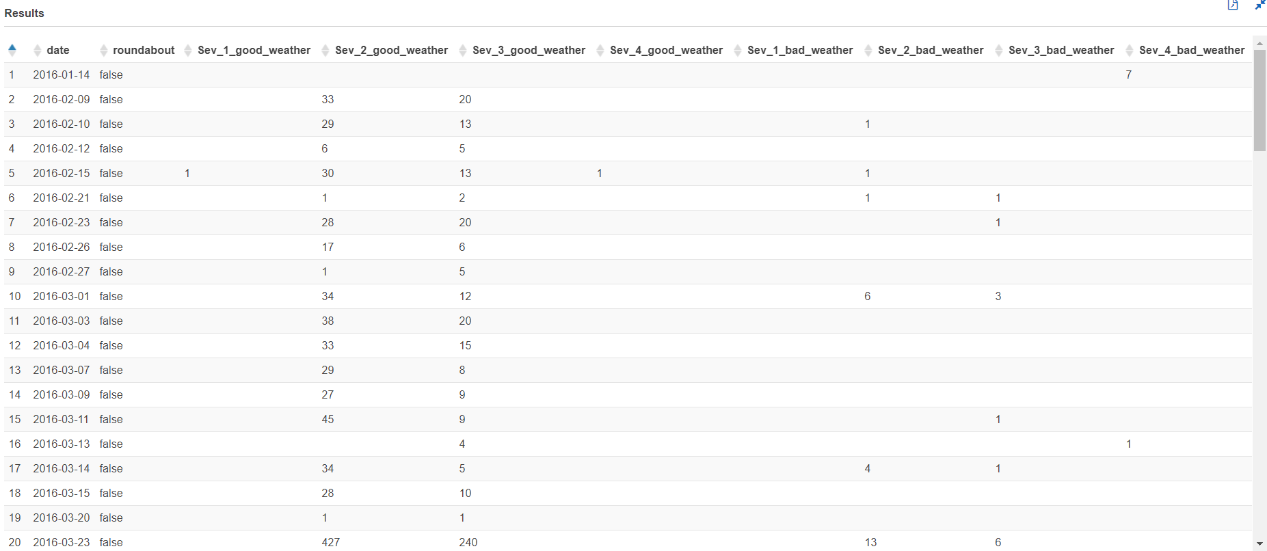

Stop:

with cte1 as

(select date_format(start_time, '%Y-%m-%d') AS date,severity,weather_condition,stop,

case

when weather_condition = 'Clear' then 'good'

when weather_condition like 'Cloudy%' then 'good'

when weather_condition = 'Drizzle' then 'good'

when weather_condition = 'Drizzle / Windy' then 'good'

when weather_condition like 'Fair%' then 'good'

when weather_condition = 'Haze' then 'good'

when weather_condition like 'Light%' then 'good'

when weather_condition = 'Mist' then 'good'

when weather_condition like 'Mostly%' then 'good'

when weather_condition = 'N/A Precipitation' then 'good'

when weather_condition = 'Overcast' then 'good'

when weather_condition like 'Partial%' then 'good'

when weather_condition like 'Partly%' then 'good'

when weather_condition = 'Patches of Fog' then 'good'

when weather_condition = 'Scattered Clouds' then 'good'

when weather_condition = 'Shallow Fog' then 'good'

when weather_condition = 'Showers in the Vicinity' then 'good'

when weather_condition = 'Small Hail' then 'good'

when weather_condition = 'Thunder in the Vicinity' then 'good'

else 'bad' end as weather_type

from us_accident_v3),

cte2 as

(select *,

case

when severity = 1 and weather_type = 'good' then 'sev1_good'

when severity = 2 and weather_type = 'good' then 'sev2_good'

when severity = 3 and weather_type = 'good' then 'sev3_good'

when severity = 4 and weather_type = 'good' then 'sev4_good'

when severity = 1 and weather_type = 'bad' then 'sev1_bad'

when severity = 2 and weather_type = 'bad' then 'sev2_bad'

when severity = 3 and weather_type = 'bad' then 'sev3_bad'

when severity = 4 and weather_type = 'bad' then 'sev4_bad'

else 'unknown_weather' end as good_bad_sev

from cte1),

cte3 as

(select date,stop,good_bad_sev,count(*) as number_of_accident from cte2 group by date,stop,good_bad_sev

order by date asc)

select date,stop,kv1['sev1_good'] as Sev_1_good_weather,

kv2['sev2_good'] as Sev_2_good_weather,

kv3['sev3_good'] as Sev_3_good_weather,

kv4['sev1_good'] as Sev_4_good_weather,

kv5['sev1_bad'] as Sev_1_bad_weather,

kv6['sev2_bad'] as Sev_2_bad_weather,

kv7['sev3_bad'] as Sev_3_bad_weather,

kv8['sev4_bad'] as Sev_4_bad_weather

from (

select date,stop,map_agg(good_bad_sev, number_of_accident) kv1,

map_agg(good_bad_sev, number_of_accident) kv2,

map_agg(good_bad_sev, number_of_accident) kv3,

map_agg(good_bad_sev, number_of_accident) kv4,

map_agg(good_bad_sev, number_of_accident) kv5,

map_agg(good_bad_sev, number_of_accident) kv6,

map_agg(good_bad_sev, number_of_accident) kv7,

map_agg(good_bad_sev, number_of_accident) kv8

from cte3

group by date,stop)

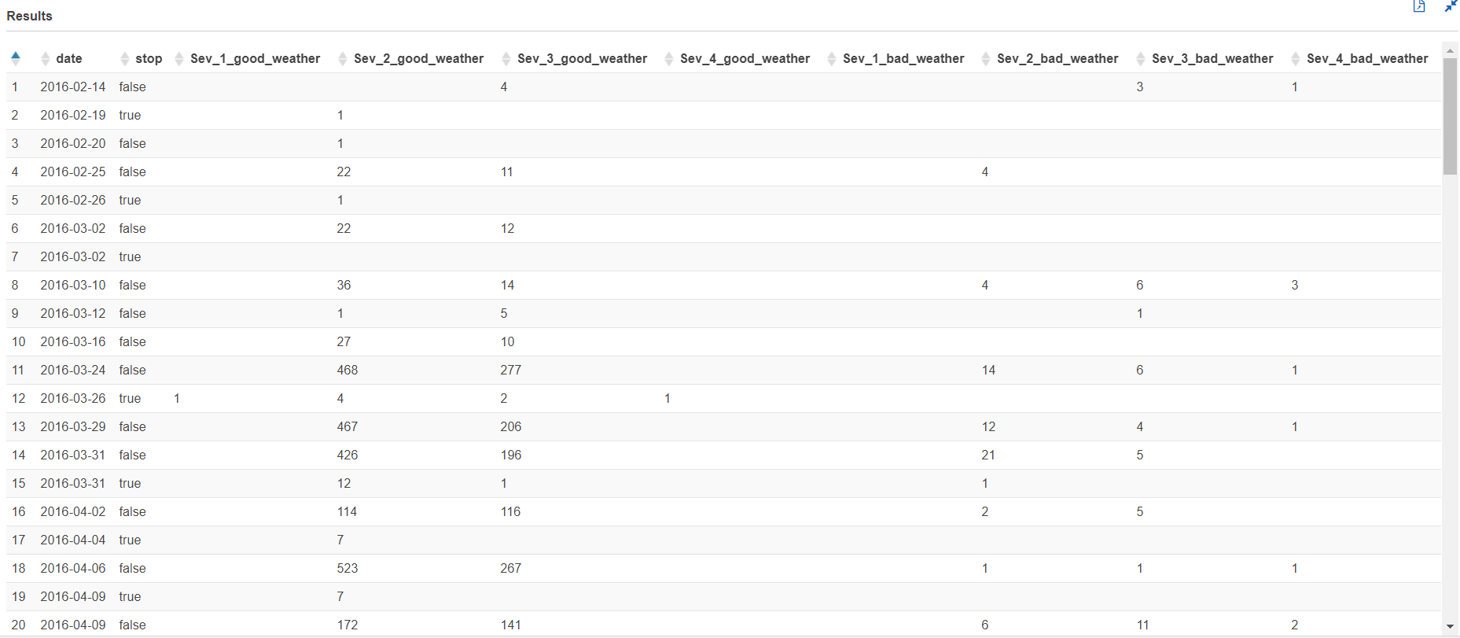

Traffic Signal:

with cte1 as

(select date_format(start_time, '%Y-%m-%d') AS date,severity,weather_condition,traffic_signal,

case

when weather_condition = 'Clear' then 'good'

when weather_condition like 'Cloudy%' then 'good'

when weather_condition = 'Drizzle' then 'good'

when weather_condition = 'Drizzle / Windy' then 'good'

when weather_condition like 'Fair%' then 'good'

when weather_condition = 'Haze' then 'good'

when weather_condition like 'Light%' then 'good'

when weather_condition = 'Mist' then 'good'

when weather_condition like 'Mostly%' then 'good'

when weather_condition = 'N/A Precipitation' then 'good'

when weather_condition = 'Overcast' then 'good'

when weather_condition like 'Partial%' then 'good'

when weather_condition like 'Partly%' then 'good'

when weather_condition = 'Patches of Fog' then 'good'

when weather_condition = 'Scattered Clouds' then 'good'

when weather_condition = 'Shallow Fog' then 'good'

when weather_condition = 'Showers in the Vicinity' then 'good'

when weather_condition = 'Small Hail' then 'good'

when weather_condition = 'Thunder in the Vicinity' then 'good'

else 'bad' end as weather_type

from us_accident_v3),

cte2 as

(select *,

case

when severity = 1 and weather_type = 'good' then 'sev1_good'

when severity = 2 and weather_type = 'good' then 'sev2_good'

when severity = 3 and weather_type = 'good' then 'sev3_good'

when severity = 4 and weather_type = 'good' then 'sev4_good'

when severity = 1 and weather_type = 'bad' then 'sev1_bad'

when severity = 2 and weather_type = 'bad' then 'sev2_bad'

when severity = 3 and weather_type = 'bad' then 'sev3_bad'

when severity = 4 and weather_type = 'bad' then 'sev4_bad'

else 'unknown_weather' end as good_bad_sev

from cte1),

cte3 as

(select date,traffic_signal,good_bad_sev,count(*) as number_of_accident from cte2 group by date,traffic_signal,good_bad_sev

order by date asc)

select date,traffic_signal,kv1['sev1_good'] as Sev_1_good_weather,

kv2['sev2_good'] as Sev_2_good_weather,

kv3['sev3_good'] as Sev_3_good_weather,

kv4['sev1_good'] as Sev_4_good_weather,

kv5['sev1_bad'] as Sev_1_bad_weather,

kv6['sev2_bad'] as Sev_2_bad_weather,

kv7['sev3_bad'] as Sev_3_bad_weather,

kv8['sev4_bad'] as Sev_4_bad_weather

from (

select date,traffic_signal,map_agg(good_bad_sev, number_of_accident) kv1,

map_agg(good_bad_sev, number_of_accident) kv2,

map_agg(good_bad_sev, number_of_accident) kv3,

map_agg(good_bad_sev, number_of_accident) kv4,

map_agg(good_bad_sev, number_of_accident) kv5,

map_agg(good_bad_sev, number_of_accident) kv6,

map_agg(good_bad_sev, number_of_accident) kv7,

map_agg(good_bad_sev, number_of_accident) kv8

from cte3

group by date,traffic_signal)

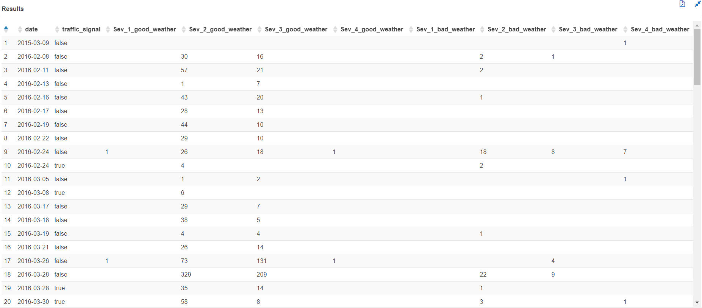

## Query 6 (Updated)

Query 6 update ------

select year(start_time) as year, week(start_time) as week, severity, count as no_of_acc from us_accident_v3

where year(start_time) >= 2016

and month(start_time) >= 2

and day(start_time) > 8

group by year(start_time), week(start_time), severity

order by year(start_time), week(start_time), severity asc;

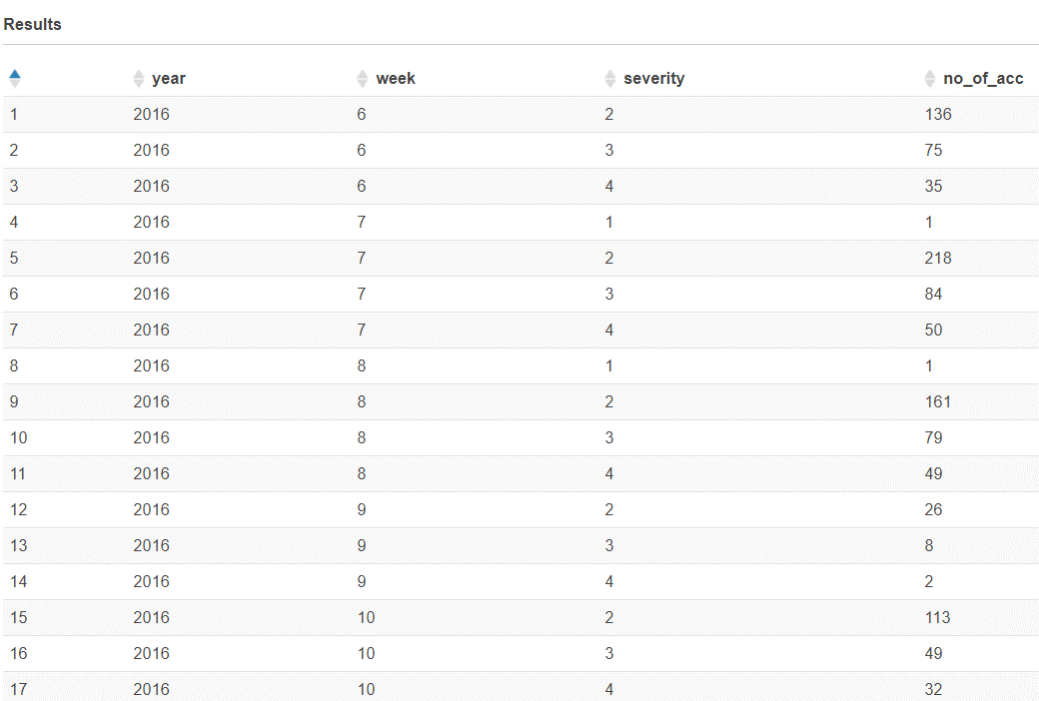

## Query 7

select severity, avg(distance) as avg_distance, max(distance) as max_distance, round(stddev(distance),2) as std_dev from us_accident_v3 group by severity order by severity asc;

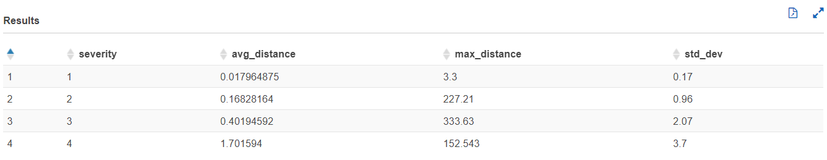

## Query 10

with cte1 as

(SELECT row, slno,pattrn, concpt, n_description,

regexp_extract_all(lower(a.n_description), (b.pattrn)) AS regexp_group1,

cardinality(regexp_extract_all(lower(a.n_description),

b.pattrn)) car

FROM base_corpus3 a

CROSS JOIN concept7 b

order by slno)

select distinct(concpt),

case

when slno >=20 and slno <25 then 20

when slno >=25 and slno <30 then 25

when slno >=30 and slno <35 then 30

when slno >=35 and slno <40 then 35

when slno >=40 and slno <45 then 40

when slno >=45 and slno <50 then 45

when slno >=50 and slno <55 then 50

when slno >=55 and slno <60 then 55

when slno >=60 and slno <65 then 60

when slno >=65 and slno <70 then 65

when slno >=70 and slno <75 then 70

when slno >=75 and slno <80 then 75

when slno >=80 and slno <85 then 80

when slno >=85 and slno <90 then 85

when slno >=90 and slno <95 then 90

when slno >=95 and slno <100 then 95

when slno >=100 and slno <105 then 100

when slno >=105 and slno <110 then 105

when slno >=110 and slno <115 then 110

when slno >=115 and slno <120 then 115

when slno >=120 and slno <125 then 120

when slno >=125 and slno <130 then 125

when slno >=130 and slno <135 then 130

when slno >=135 and slno <140 then 135

when slno >=140 and slno <145 then 140

when slno >=145 and slno <150 then 145

when slno >=150 and slno <155 then 150

when slno >=155 and slno <160 then 155

when slno >=160 and slno <300 then 160

when slno = 300 then 300

end as slno,

sum(car) over (partition by concpt) as freq

from cte1 where car>0

order by slno;

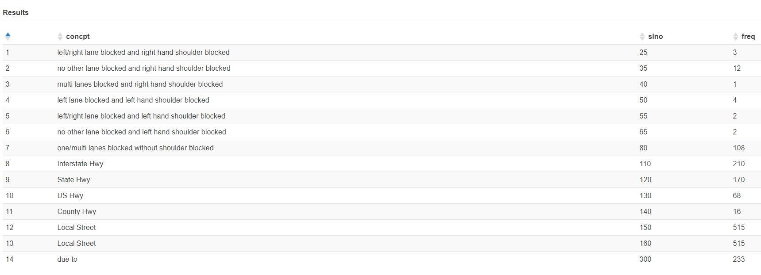

## Query 13 (Updated)

select state, start_date, avg_prec,

sum(avg_prec) over (partition by state order by start_date,avg_prec) as run_total

from

(select state, date_format(start_time, '%Y%m') AS start_date, avg(tot_prec) AS avg_prec

from (

select state,zipcode, start_time, date_diff('second', start_time, end_time) AS dur, "precipitation" AS prec,sum("precipitation") OVER (partition by state,

date_format(start_time, '%Y-%m-%d'),zipcode order by start_time) AS tot_prec,rank() OVER (partition by state,

date_format(start_time, '%Y-%m-%d'),zipcode order by start_time desc ) AS rnk

from us_accident_v3 where

--state='CA' and

(lower(weather_condition) like '%rain%' or lower(weather_condition) like '%cloud%')

and "precipitation" > 0.0

and zipcode is not null

order by state, date_format(start_time, '%Y-%m-%d'),zipcode, start_time

)

where rnk=1

group by state, date_format(start_time, '%Y%m')

order by state, date_format(start_time, '%Y%m'))

